TASK # 1
A realistic photo of a young girl praying in the room alone in the holy month of ramzan during sunset, soft golden lighting, calm and happy mood, high mood, high quality, detailed background

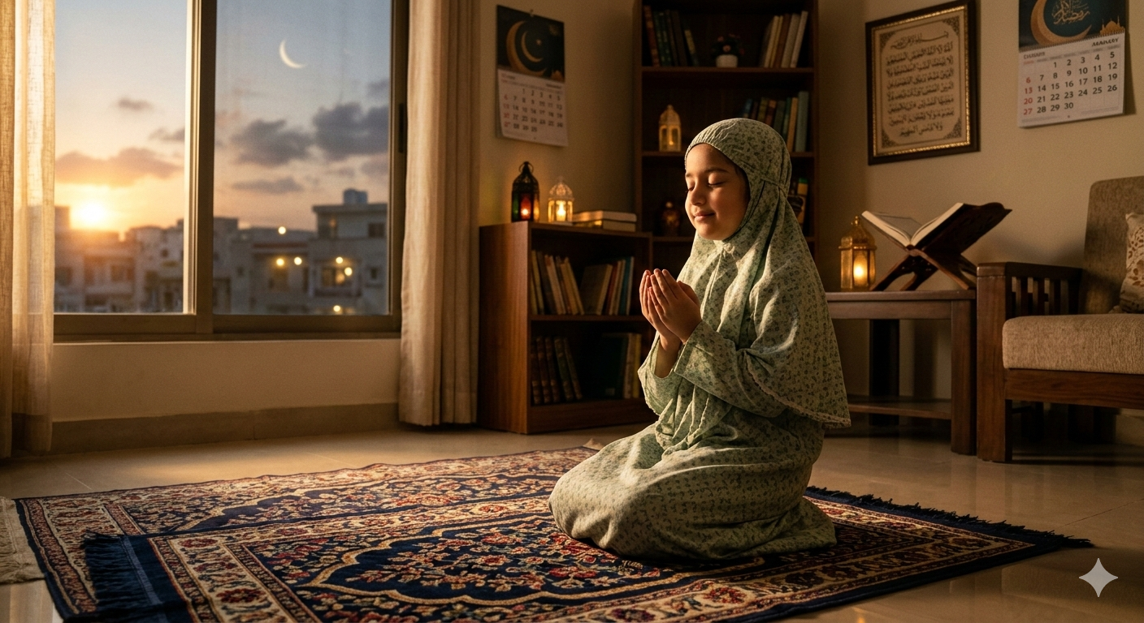

TASK # 2
A 3 second cinematic scene in Karachi, Pakistan during Ramadan at sunset. A kind young girl wearing a simple hijab distributes free food boxes to poor people sitting by the roadside. Warm golden sunset light reflects on the wet street. The girl smiles softly while handing food to an elderly man. Calm, emotional and hopeful atmosphere. Soft lantern lights and blurred city buildings of Karachi in the background. Cinematic composition, shallow depth of field, smooth slow camera movement, slight slow motion, rain droplets visible, ultra realistic, 720p quality, warm color grading.

See in link below
Assignment5 AI Video.mp4

OR
https://github.com/ammar247247/Assignment-1/blob/main/Assignment5%20AI%20Video.mp4

Note: Assignments, Image and Video also available on github shared linked
https://github.com/ammar247247/Assignment-1

